# JS Advanced: Retake Exam - 10.12.19

Exam problems for the ["JavaScript Advanced" course @ SoftUni](https://softuni.bg/courses/js-advanced). Submit your solutions in the SoftUni Judge system at <https://judge.softuni.bg/Contests/Compete/Index/1850#0> .

# Problem 1. Christmas Gifts Delivery (DOM Manipulation)

### Use the given skeleton to solve this problem.

### Note: You have NO permission to change directly the given HTML *(index.html file)*.

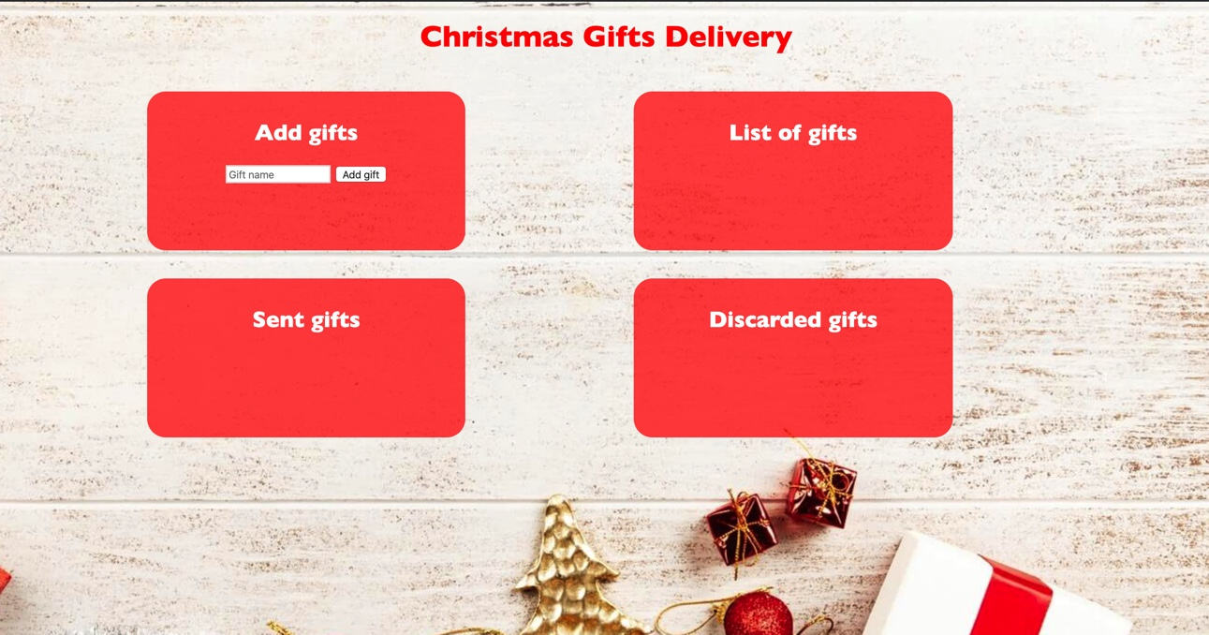

### Your Task

Write the missing JavaScript code to make the Christmas Gifs Delivery application work as expected.

You should be able to **add** new gifts to the list of gifts.

Each product has **name**. When you click the **[Add gift]** button, a new **list item** should be added to the **List of gifts**. To each list item you should put a **class “gift”**. Upon clicking the **[Add gift]** button you should **sort** the gifts **in alphabetical order** and you should **clear the input field.**

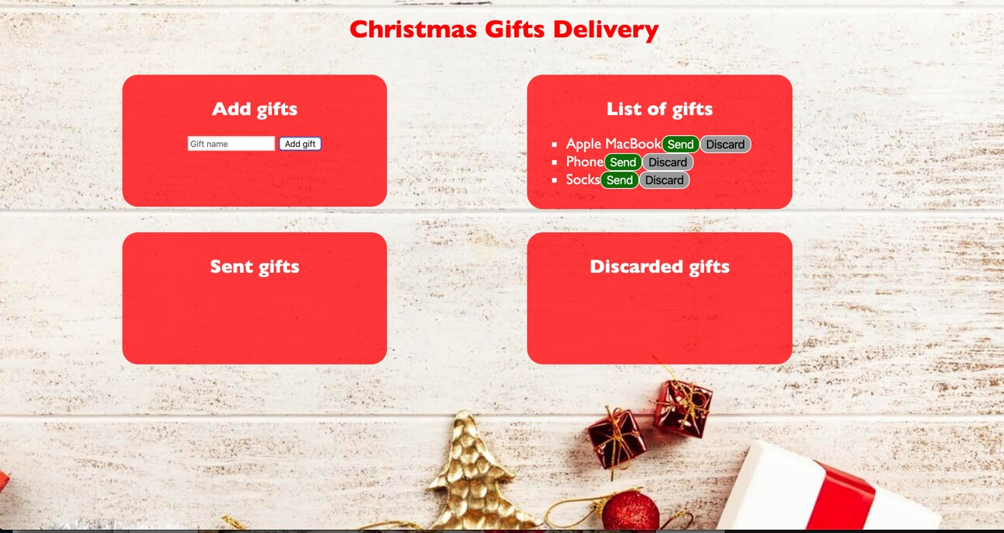

The new item should have the **following structure**:

* Append two buttons to each list item
  + Add class **“gift”** to each list item
  + **[Send]** button with id **“sendButton”**
  + **[Discard]** button with id **“discardButton”**

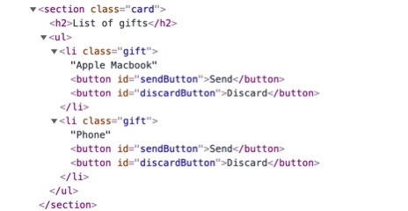

When you click the **[Send]** button you should move the list item to the **Sent gifts** section. **Important!** Do not move the entire list item, but only the name of the gift. You should leave the buttons behind.

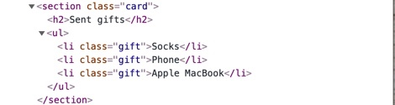

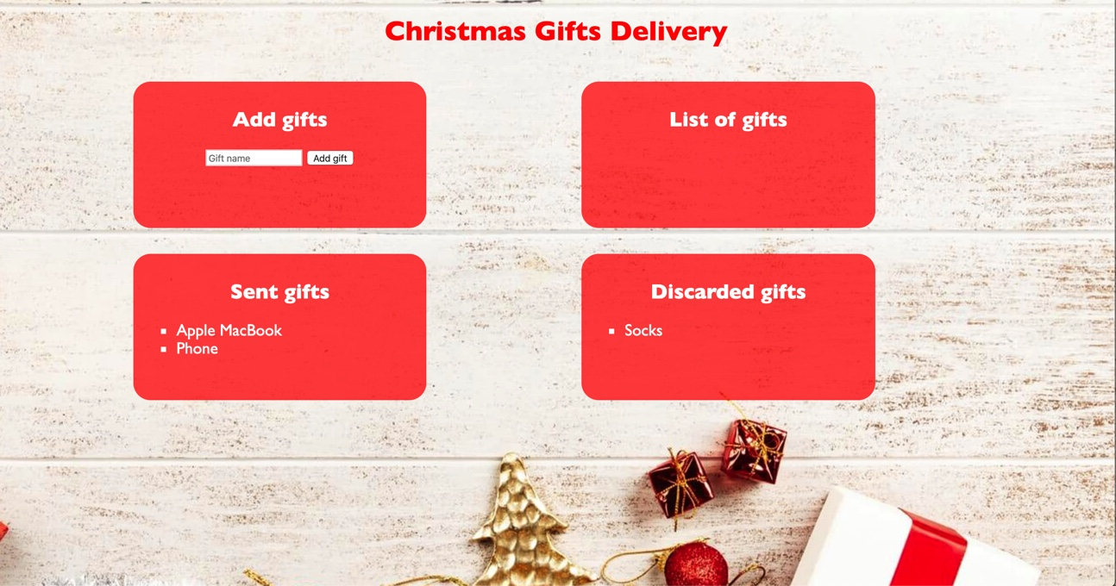When you click the **[Discard]** button you should move the list item to the **Discarded** gifts section. 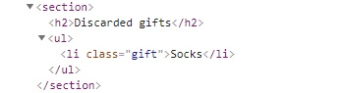**Important!** Do not move the entire list item, but only the name of the gift. You should leave the buttons behind.

function solution() {

    //I. Взимаме входните данни

    //1. UL листовете, които ще пълним с информация

    //2. Input - от него ще четем потребителски вход

    //3. Бутон - закачаме eventListener за него;

    //II. При 'click' на add се изпълнява фунцкията addgift :

    //1. Създаваме <li> елемент с properties name and class, за който закачаме :

    // - sendBtn и discardBton, които сме създали; Закачаме <li> елемента накрая

    // за UL - gifts;

    //2. Сортирането на UL gifts става по референция - сортираме масива gifts.children == <li> и закачаме елементите

    // отново за UL gifts, като така пренареждаме масива по референция.

    //3. За да преместим елементите в "Send gifts" или "Discarded Gifts", закачаме

    //eventListeners за двата бутона, които създадомхе за всеки <li>;

    //4. При 'click' на sendBtn или discardBtn се задействат два event handlers -

    // sendGifts() и discardGifts();

    const [gifts, sent, discarded] = document.querySelectorAll('section ul');

    const input = document.querySelector('input');

    document.querySelector('button').addEventListener('click', addgift);

    function addgift() {

        const name = input.value;

        input.value = '';

        const element = createE('li', name, 'gift');

        const sendBtn = createE('button', 'Send', 'sendButton');

        const discardBtn = createE('button', 'Discard', 'discardButton');

        element.appendChild(sendBtn);

        element.appendChild(discardBtn);

        gifts.appendChild(element);

        //за да извикаме самата функция, а не event

        sendBtn.addEventListener('click', () => sendGift(name, element));

        discardBtn.addEventListener('click', () => discardGift(name, element));

        sortGifts();

    }

    function sendGift(name, gift) {

        //remove element from original list

        gift.remove();

        //create new list item like the removed one

        const element = createE('li', name, 'gift');

        //add element to new list

        sent.appendChild(element);

    }

    function discardGift(name, gift) {

        //remove element from original list

        gift.remove();

        //create new list item like the removed one

        const element = createE('li', name, 'gift');

        //add element to new list

        discarded.appendChild(element);

    }

    //Сортираме масива от gifts и го връщаме обратно . По този начин ще заменим

    //елементите в него, този път сортирани

    function sortGifts() {

        Array

            .from(gifts.children)

            .sort((a, b) => a.textContent.localeCompare(b.textContent))

            .forEach(g => gifts.appendChild(g));

    }

    function createE(type, content, className) {

        let result = document.createElement(type);

        result.textContent = content;

        if (className) {

            result.className = className;

        }

        return result;

    }

}